Stress Journal Date:_________________

I feel:



How much: Sleep:_____ Alcohol:____

I experienced: Stomach Issues  Headache  Muscle Pain 

Today I relieved stress by:

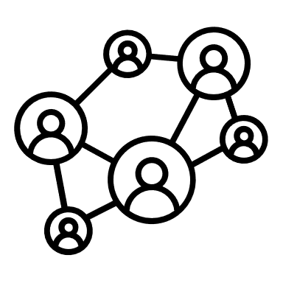Supporting or being supported by my friends and family.

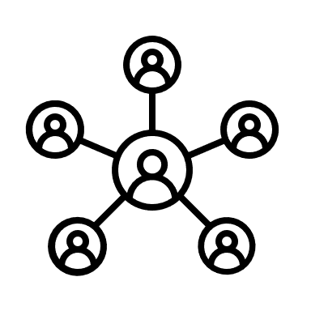Networking with my co-workers.

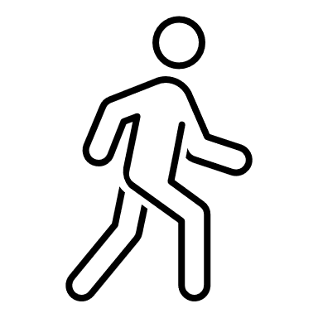Taking breaks during my workday to move around.

Exercising for 30 minutes.

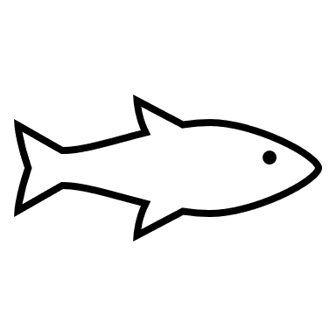Eating an Omega-3.

Choosing healthier options.

Limiting my caffeine consumption to 2 cups/day.

Turning off my screens at least 1 hour before going to bed.

Doing my most important tasks first thing in the day.

Consciously recognizing what I can control and letting go of what I cannot control.